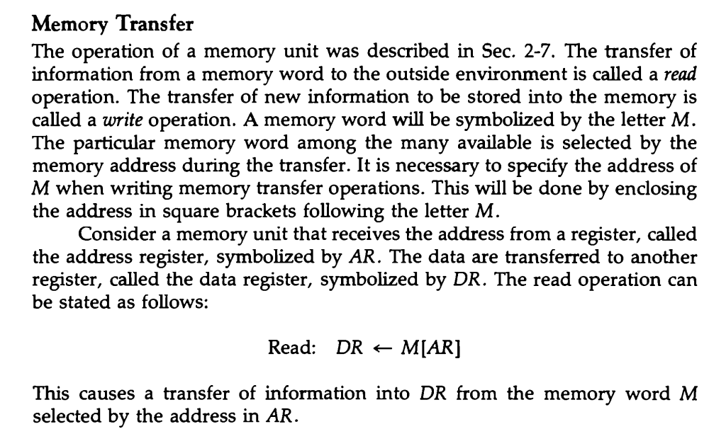
and the address is in AR. The write operation can be stated symbolically as follows:
Write: M[AR] R1
This causes a transfer of information from R1 into the memory word M selected by the address in AR.

